

**Purbanchal University**

**College of Information Technology & Engineering**

**Subidhanagar, Tinkune, Kathmandu**

Project Report

On

**Supermarket Billing System**

**Submitted by**

Student 01 (Symbol no.)

Student 02 (Symbol no.)

Student 03 (Symbol no.)

Batch: 2020

Faculty: Science & Technology

Program: Bachelor In Computer Engineering

**Submitted to**

Department of Science & Technology

Date of Submission: 16 August, 2022

Date: 16 August, 2022

**LETTER OF APPROVAL**

We, the supervising committee of CITE College, have successfully supervised and approved the Project report entitled “**Supermarket Billing System”** submitted by project members (Sujan Thapa, Raman Chaudhary & Anish Chaudhary), BIT- II Semester. During our supervising period, we found that the corresponding report has been prepared as approved by this department in prescribed format of Bachelor of Information Technology (BIT), Faculty of Science & Technology. This report is forwarded for further examination.

With best regards,

………………………… ………………………….

Project Supervisor Internal Examiner

…………………………

External Examiner

# Acknowledgement

With immense please, we are presenting “Supermarket Billing System” report as part of curriculum “Bachelor of Information Technology”. We wish to thank all the people who gave us unending support.

We express our profound thanks to our Head of Department (HOD) Mr. Saroj Dahal, Project Supervisors Assistant Professors (Mr. Rabi Raj Karn & Mr.Bishal Patel) and all those who have indirectly guided and helped us in preparation of this project.

We would also like to thank Purbanchal University (PU) as well as College of Information Technology & Engineering (CITE) for the course and the project assigned which helped in our study and developing skills like code and project management.

# abstract

Supermarket Billing System in market are used in day to day life of peoples. It’s easy method in the supermarket to buy and pay bills from the systematic method. In past peoples have to pay only from the money in hand but nowadays peoples can pay from smartphones, debit card, credit card, etc. This have made the bills payable system flexible and comfortable.

We have created the supermarket billing system having features as used in market from C++ language. It’s a system same as simple console application without graphics. In our project we have made admin and costumers section which have separate functions to operate in separate section. Administrator can add products, edit products, delete products, like they can do operating work as an operator in the system. Customer can be able to choose products they buy and can choose the way of payment like QR code or Bill and process further. File handling has been used to record data’s in file. In overall this whole project will give the overview of “Supermarket Billing System”.

[***Keywords:*** *QR, admin, billing, QSR, Customers, Online, DMA, OOP, GUI* ]

# table of contents

**Table of Contents**

Acknowledgement i

Abstract ii

**Lists of Figures………………………………………………………………………vi**

**Lists of Tables………………………………………………………………………vii**

Chapter 1 Introduction 1

1.1 Introduction of Project 1

1.2 Problem Statement 1

1.3 Objective 2

1.4 Aim 2

1.5 Motivation 3

1.6 Scope 3

1.7 Applications 4

1.8 Feasibility Study 4

1.8.1 Technical Feasibility 4

1.8.2 Economic Feasibility 4

1.8.3 Operational Feasibility 5

Chapter 2 Literature Review 6

2.1 Study on Existing Systems 6

2.1.1 Study of Supermarket Billing System made by students of Rajalaxmi Engineering College 6

2.2 Relevance of Literature Review with Project 7

Chapter 3 System Requirements 9

3.1 Tools & Technologies 9

3.2 Files Extensions 9

3.3 Hardware Requirements 9

3.4 Software Requirements 9

3.5 Team Structure 10

Chapter 4 Design & Methodology 11

4.1 Block Diagram of Supermarket Billing System 11

4.2 Activity Diagram 12

4.3 System interface 13

4.3.1 Main Menu 14

4.4 Algorithm 18

4.5 Flowchart 21

4.6 Implementation Table 22

4.7 Implementation Details 23

4.8 Object Oriented Programming 23

4.9 File Structure 24

4.10 Class & Objects 24

4.11 Inheritance 25

4.12 String 26

4.13 Functions 27

4.14 Gantt Chart 28

Chapter 5 Expected Output 29

Chapter 6 Testing 30

6.1 Unit Testing 31

Chapter 7 Conclusion & Further works 32

8 References 34

Appendix 35

**Lists of Figures**

Fig 4.1: Block Diagram of Supermarket Billing System …………………………… 11

Fig 4.2: Supermarket Billing System Activity Diagram …………………………….12

Fig 4.10: Flowchart ………………………………………………………………….21

**List of Tables**

Table 3.1: List of Team members …………………………………………………..10

Table 4.1: Preprocessor directives …………………………………………….……22

Table 4.2: Program structure ……………………………………………………......23

Table 6.1: Inputs & operations – Unit Testing …………………………………..….31

Table 6.2: Output – Unit Testing ………………………………………………..…..31

# chapter 1 introduction

## 1.1 Introduction of Project

Supermarket is the place where customers come to purchase their daily using products and pay for that. So, there is a need to calculate how many products are sold and to generate the bill for the customer.

In this project, we will see how to build the**billing system of supermarkets**project using C++ programming language.

This billing system in supermarkets is a straightforward console program written in C++ with no visuals. This project will teach you how to use supermarket market billing system with easy way. It will show the overview of the advance systems which can be developed in future and use in market. This whole project shows the concept and features same as the systems available in markets.

There are only a few features, the project is quite straightforward to comprehend. For understanding the source code will provide you an idea of how to operate with files, for example add, remove, update, and search data or information inside and outside of them.

## 1.2 Problem Statement

**Maintaining more than one store** – Those who have a chain of stores or even more than one store, product/item lookup, inventory transfer, checking the overall sales report and more becomes difficult.

**Level of efficiency** – In case of both the retail stores and QSRs, managing customers and billing during the rush hours become tough. Hand billing or billing through a cash register takes time and serving more number of customers in less times becomes an impossibility.

**Maintaining payments and receivables** – A cash register does not provide you the option to keep a check on your payments and receivables. So, without a billing solution, you need to keep track of these things manually, which again takes up a lot of your time.

**Keeping track of stock** – Keeping track of stock is one of the most important things for a business. But a cash register cannot provide any kind of help in this regard.

**Maintaining customer satisfaction** – Customer satisfaction is of foremost importance for any business. However, if billing takes time, if there’s a problem with the delivery, etc., it becomes hard for a business to retain the customers.

## 1.3 Objective

* The developed project will be user friendly.
* ‘Supermarket Billing will reduce paper work in the supermarket store.
* “Billing System” is computerized system therefore it can handle very large product records and prepare any report in desired format.
* Retail Supermarket Billing System can automatically calculate large calculation while billing.
* Customer satisfaction can be made possible.

## 1.4 Aim

* To reduce the traditional way of buying and selling product.
* To reduce the time and cost.
* To maintain the data of supermarket.
* It helps to provide services to their customers in effective manner.

## 1.5 Motivation

Supermarket billing system is digital system which is used to manage their products and items in efficient way that helps the customer to buy the products and it helps the supermarket to maintain in easy way.

Before making the project we see the problem facing by the customer. So, we decide to manage a digital program that helps all the customer and special to supermarket system. We see this system is used by every big mart for billing purpose that is not so effective. We have made according to need of customer and every supermarket used this system.

Hence, main aim is to developed project will be user friendly Retail Supermarket Billing System can automatically calculate small and medium calculations of the store.

## 1.6 Scope

Scope of this project is to investigate and design a software solution which can facilitate both customer and salesperson in performing their daily tasks. Improving efficiency and helping them to be more productive. This project will provide a solution through which salesperson can easily manage, handle and generate all required information in their respective format when needed. It provides quick way of operation by capturing the manual the bill details, financial data, and automating them. It will help them to manage the bill details, financial data, and historical data and also in producing documents of different formats for different customers. This solution will help salesperson in reducing effort spend on managing many bills. It will also provide them opportunity to explore possibility of generating documents, managing financial details. This system will help the salesperson to manage in fast billing. It will help to maintain the data of the purchased items. It also gives bill to the customers.

## 1.7 Applications

* Smart Inventory Management
* Shelf space management
* Loss Prevention
* Scale Management
* Fast End Accounting
* Real time payment (online, cash)
* Security

## 1.8 Feasibility Study

From all the study done regarding the feasibility of the proposed system, it can be said that the system is slightly feasible. Feasibility study on the project can be categorized in the following:

### 1.8.1 Technical Feasibility

The proposed system is technically slightly feasible. The proposed system during data collection or assumption for test & training purposes requires huge data’s when we use it in the real time. The system provides supermarket billing system information of the customers, admins, etc. It provides the details of market with all the features.

### 1.8.2 Economic Feasibility

This study is carried to maintain a secure and time saving environment & further it can may be used as a business purpose. This system can be further modified with the new features and technology which will be implemented in future as “supermarket billing system” for the every local and private store. It can be a successful platform because of its huge use in today’s world.

### 1.8.3 Operational Feasibility

Operational Feasibility aspects of the project are to be taken as an important part of the project implementation. Therefore, the proposed system is slightly feasible from operational point of view. This system is further modified with the new features and technology which be implemented in future as supermarket billing system for every local and private stores.

# chapter 2 literature review

Supermarket Billing System service is everywhere in stores nowadays, which are providing many useful features to customers and admins for the easier of the selling and buying goods & services. In our country also almost every store uses the Billing System which gives experience to the users of new technology.

To understand more about the Supermarket Billing System we have analyze the existing systems documentation found in the internet. There are huge numbers of documentation found but we have choose the documentation that had been implemented by the students of Rajalaxmi Engineering College, Chennai.

## 2.1 Study on Existing Systems

There is an existing system made by the students of Rajalaxmi Engineering College, Chennai.

### 2.1.1 Study of Supermarket Billing System made by students of Rajalaxmi Engineering College

Fig 2.1: REC Supermarket Billing System

The Supermarket Billing System shown in Figure 2.1 is developed by the Rajalaxmi Engineering College. It is built in a console with C++ programming, which is little bit similar to the software used in the small store and markets.

There are options available for the use of system which guides the user to use it. This system is built for fast data processing and bill generation for supermarket customers. It also allows the customer to purchase and pay for the items purchased. The users will consume less time in calculation and the sales activity will be completed within a fraction of seconds whereas in a manual system will make the user to write it down which is a long procedure and it also consumes a lot of time. Because of this software, paper work will be reduced and the user can spend more time on monitoring the supermarket. The project will be user friendly and easy to use. This project is helpful to computerize the bill report and generating the items details. The billing data is a vast collection of product name, price and other product specific data. A product when billed is searched and its price is added to the bill based upon the product quantity. The system also contains discounts on various products so that the product is offered at discounted price while billing. The supermarket billing system is built to help supermarkets calculate and display bills and serve the customer in a faster and efficient manner. This software project consists of an effective and easy GUI to help the employees in easy bill calculation and providing an efficient customer service. With the continuous development and improvement of computer technology, communication technology, network technology, scale database technology, the commercial supermarket has become a developing technology worldwide.

This system is built for fast data processing and bill generation for

supermarket customers. It also allows the customer to purchase and pay for the

items purchased. The users will consume less time in calculation and the sales

activity will be completed within a fraction of seconds whereas in a manual

system will make the user to write it down which is a long procedure and it also

consumes a lot of time. Because of this software, paper work will be reduced

and the user can spend more time on monitoring the supermarket. The project

will be user friendly and easy to use. This project is helpful to computerize the

bill report and generating the items details. The billing data is a vast collection

of product name, price and other product specific data. A product when billed is

searched and its price is added to the bill based upon the product quantity. The

system also contains discounts on various products so that the product is offered

at discounted price while billing. The supermarket billing system is built to help

supermarkets calculate and display bills and serve the customer in a faster and

efficient manner. This software project consists of an effective and easy GUI to

help the employees in easy bill calculation and providing an efficient customer

service. With the continuous development and improvement of computer

technology, communication technology, network technology, scale database

technology, the commercial supermarket has become a developing technology

worldwide.

## 2.2 Relevance of Literature Review with Project

Supermarket billing system is used in every supermarket but nowadays people using more advance system. Before billing system is used for specific purposes only but compare to now day it is used for different purposes. In our project we design as per requirements of customer and staffs. It helps us according to necessity of administer of the supermarket it includes all the records and billing system of sell and other details.

This software project is a traditional supermarket billing system with some added functionality. This system is built for fast data processing and bill generation for supermarket customers. The billing system consist of an object-oriented programming. The billing database is a vast collection of product name, price, and other product specific data. A product when billed is searched form the database and its price is added to the bill based upon the product quantity. The system also contains discounts on various products so that the product is offered at discounted price while billing. The supermarket billing system is built to help supermarkets calculate and display bills and serve the customer in a faster and efficient manner. This software project consists of an effective and easy to help the employee in easy bill calculation and providing an efficient customer service, which is related to our studied project of Rajalaxmi Engineering College student’s project.

# chapter 3 system Requirements

## 3.1 Tools & Technologies

We have developed our entire project in Visual Studio Code, which is the famous IDE for the programmers in today’s world because of its faster performance and easy to use.

## 3.2 Files Extensions

The coding is stored in C++ file extensions like “.hpp” and “.cpp”.

## 3.3 Hardware Requirements

Processor: i3 or higher & similar

RAM: 2 GB or higher

Memory: 200 MB or higher

## 3.4 Software Requirements

Operating System: Windows

IDE: Visual Studio Code, Dev C++, Code Blocks

## 3.5 Team Structure

|  |  |  |
| --- | --- | --- |
| Team Members | Symbol no. | Task Done |
| Student 01 | -------- | Research, Coding, Debugging & Documentation |
| Student 02 | -------- | Research, Coding, Debugging & Documentation |
| Student 03 | -------- | Research, Coding, Debugging & Documentation |

Table 3.1: Containing List of Team Members

# chapter 4 design & Methodology

A system design is conceptual model that define structure, behavior and more view of the system. It is a formal description and representation of system organized in a way support rezoning about the structure and system architecture can comprise the system component, the extremely visible of those component, and the relationship between them. It provide a platform that will work together to implement whole system.

## 4.1 Block Diagram of Supermarket Billing System

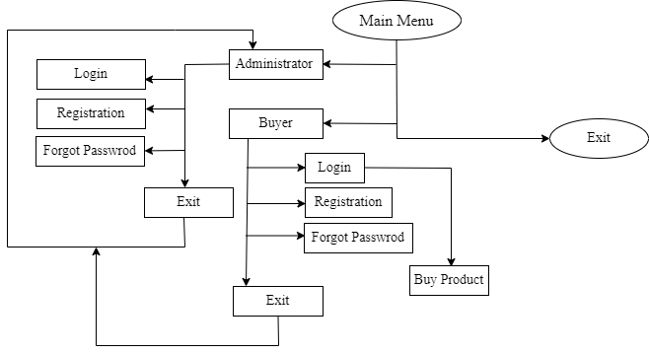

Fig 4.1: Block Diagram of Supermarket Billing System

In the above diagram, the whole process of our developed system is shown. In this system first of all administrators have to registers in to the system and they have to login to it to use features like adding product, delete products, edit, etc. In another side buyer can use the system when the system is opened. They can go to buyer option and directly purchase the products. System can be shut down when the use for the day is fulfilled by pressing exit option in it.

## 4.2 Activity Diagram

Activity diagram is basically a flowchart to represent the flow from one activity to another activity. The activity can be described as an operation of the system.

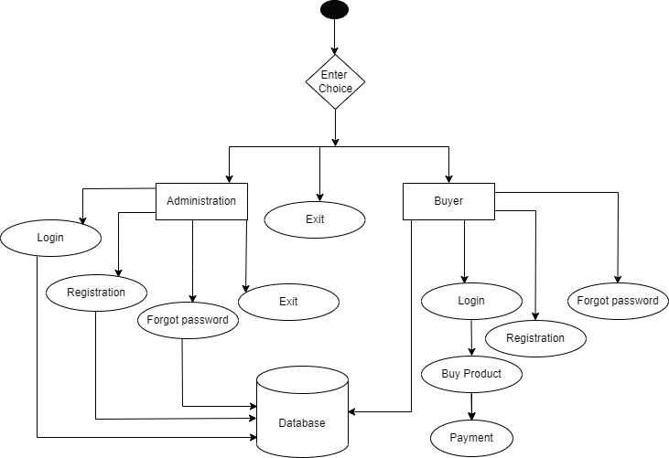

Fig 4.2: Supermarket Billing System Activity Diagram

In above figure 4.2, we can see that how system works internally using all the system attached. We see that every time when we perform any operation it executes information from databases. The external source provides the operation information to the database organs and database organs perform certain operations and gives the related output to the external source which gives the system a full operational method.

## 4.3 System interface

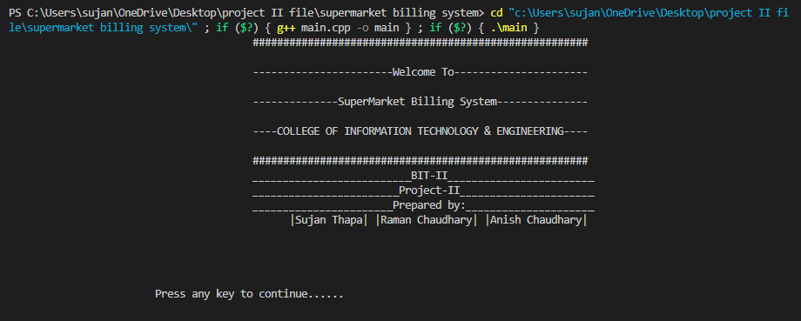The software design is simple as Supermarket Billing System available in markets with some features. The software contains mainly following sections:

Fig 4.3: System Interface

### 4.3.1 Main Menu

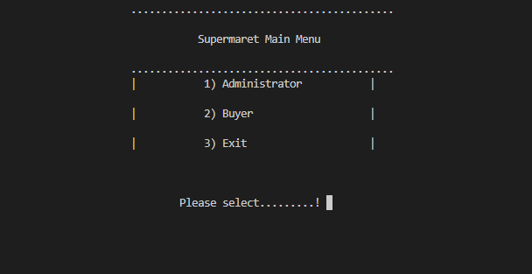In main menu section the console window is displayed showing the options as administrator, buyer & exit the system. From this section customer & administrator can go into the system and perform the task respectively.

Fig 4.4: Main menu

#### Administrator

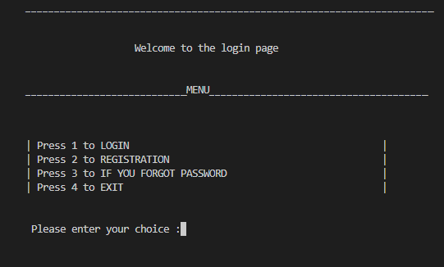In administrator section we see the login, registration, forgot password and exit options from where we can perform specific tasks.

Fig 4.5: Administrator section

* **Login**

Here we can see the login window from where we can enter into the system and do work that are defined for the administrator in this system. The administrator can perform following tasks:

* Add product

Here administrator can add the products into the system and set its price, code, discount price and save it into the system.

* Modify product

Administrator can modify the products which are already entered into the system and save it.

* Delete product

Administrator can delete the useless and other’s products that have to be removed from the system from this section.

* Back to main menu

From here administrator can directly go back main menu section of the project.

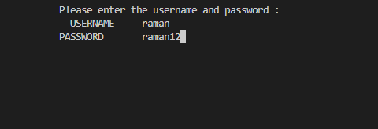

Fig 4.6: Login Section

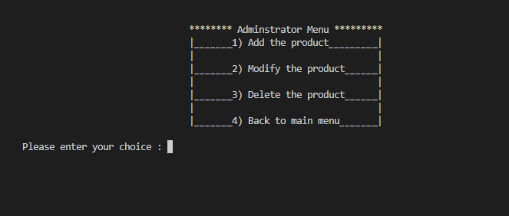Fig 4.7: Administrator Menu

* **Registration**

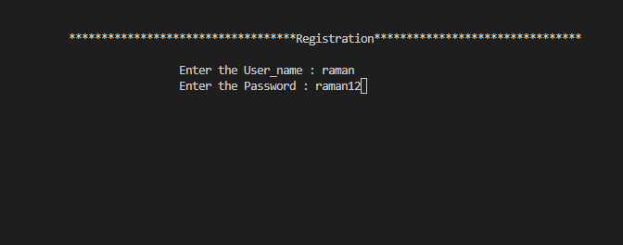In this section, administrator can register him/her as admin user and use the system to maintain it.

Fig 4.8: Registration Section

* **Forgot Password**

From here the admin can see his/her password if he/she forgets the password of the system used for the login.

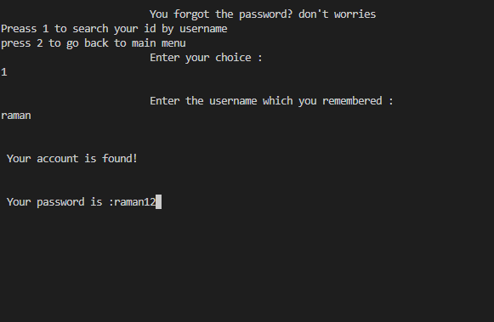

Fig 4.9: Password Forgot window

* **Exit**

From here the admin can go back to the main menu section and choose other options for using the system.

1. **Buyer**

In buyer section we can see the options like buy product & go back. From this section customer can buy goods and pay the bill through the online payment or cash payment.

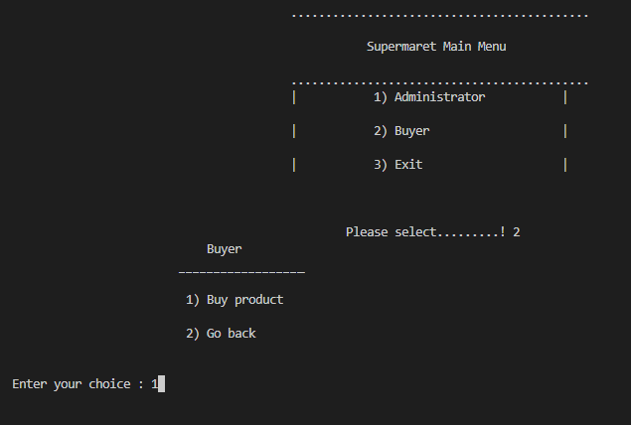

Fig 4.10: Buyer window

1. **Exit**

From this option user can directly go to the administrator main menu section and perform the desire task.

## 4.4 Algorithm

**Steps**

1. Start with console window showing project name
2. Display window showing following choices
3. Administration

Display window Showing Login page

1. Login

* Add Product
* Enter Product Code
* Enter Product Name
* Enter Price
* Enter Discount

Record inserted and goto ‘a’

* Modify Product
* Enter Product Code (Old)
* Enter Price Code (New)
* Enter Product name
* Enter price
* Enter Discount

Record Edited and goto ‘a’

* Delete Product
* Enter Product Code to Delete Product

Product deleted successfully goto ‘a’

* Back to Main Menu

goto ‘II’

1. Registration

* Shows window to register administration (username & password) and goes to ‘1’ after registration successful

1. Forgot Password

* Shows the window to search account with username and if username matched then it shows the password of user and goes 1

1. Exit

* Exits from the system

1. Buyer
2. Buy Product

(Shows the lists of product & Gives to place the order)

* Enter Product Code
* Enter Product Quantity
* Do you want to buy more, if ‘y’ then repeat from enter product code again else process further

(Goes to the payment method)

* Online Payment (fonepay Payment)
* Shows QR code to scan & pay

(Enter to print bill)

* Prints bill receipts

(goto 2)

* Direct method (Cash payment)
* Enter your total payment

(Enter to print bill)

* Prints bill receipts

(goto 2)

1. Go back

goto II

1. Exit

(Thanks for visiting our Supermarket)

1. Exits the system.

## 4.5 Flowchart

Fig 4.11: Flowchart

## 4.6 Implementation Table

We have used “.h” header file and preprocessor directives like:

|  |  |
| --- | --- |
| **Library functions** | **Description** |
| #include<iostream> | Contains all the functions of program such as cout, cin, etc. |
| #include<fstream> | Represents the file stream, such as ofstream (open, write), ifstream (open, read), etc. |
| #incluce<string.h> | Used for string handling functions. |
| #include<stdlib.h> | Used for DMA functions |
| #include<conio.h> | Used & stands for console input & output |
| #include “windows_screen.hpp”  #include “customer.hpp”  #include “delay.hpp”  #include “payment.hpp”  #ifndef …, #define…, #endif | Used to connect multiple files which makes easier to build projects in an effective way |

Table 4.1: preprocessor directives

## 4.7 Implementation Details

The function used in the program are used to maintain the program simpler and make a better program structure and work with team members.

|  |  |
| --- | --- |
| Files | Description |
| main.cpp | Initialize the program & executes all the other “.hpp” files |
| windows_screen.hpp | Displays the home screen at the start of the system |
| customer.hpp | Main program file that contains all the functions such as (login, registration, password forgot, add product, edit product, delete product, buy product, etc.) |
| delay.hpp | Used to hold or sleep screen |
| payment.hpp | Used for the payment method section |
| record.txt, recorder.txt | Used to store login credentials of the admin & customers respectively |
| database.txt | Used to store the details of products in the system |

Table 4.2: program structure

## 4.8 Object Oriented Programming

The major motivating factor in the invention of object-oriented approach is to remove some of the flaws encountered in the procedural approach. OOP treats data as a critical element in the program development and does not allow it to flow freely around the system. It ties data more closely to the function that operate on it, and protects it from accidental modification from outside function. OOP allows decomposition of a problem into a number of entities called objects and then builds data and function around these objects.

Concepts of OOP are:

* Class
* Objects
* Data abstraction & encapsulation
* Inheritance
* Polymorphisms
* Template
* Namespace, etc…

## 4.9 File Structure

A CPP file structure is simple as compared to the header files. The main purpose of such an implementation file is **to split the interface from the implementation**. This results in declarations of all the member functions in a header file and their details inside the CPP file.

In our project, File management was taken into consideration while developing this project. Different source and header files are used according to their use/functionality in program. This process of working with different files makes development process easier while working in the group.

## 4.10 Class & Objects

A class is a user-defined data type that we can use in our program, and it works as an object constructor, or a "blueprint" for creating objects.

Anything created under class that determines the behaviors and states of the class can be called as object of that class.

“Class and Objects” are the main approaches of object oriented programming which can give user a real time experience and more features to build project for real world.

Classes allows to group functions, variables, and even other classes into one contained objects that doesn’t interface with other objects.

Functions of class can be called from the main function by making object of class type.

Syntax and example of class & objects:

#include<iostream>

using namespace std;

class class_name{

//body of class

//private data members;

//public data members;

};

int main(){

class_name object;

object.functions_of_class;

return 0;

}

## 4.11 Inheritance

Inheritance is a feature or a process in which, new classes are created from the existing classes. The new class created is called “derived class” or “child class” and the existing class is known as the “base class” or “parent class”. The derived class now is said to be inherited from the base class.

Inheritance is used where we need one class features in another class. It derives all the features of base class to derived class and makes easy to use all features in project.

Syntax & example:

#include<iostream>

using namespace std;

class class_A{

//body_of_class_A;

}

class class_B: public class_B{

//body_of_class_B;

}

## 4.12 String

Strings are actually one-dimensional array of characters terminated by a null character '\0'. Thus a null-terminated string contains the characters that comprise the string followed by a null. The following declaration and initialization create a string consisting of the word "Hello". To hold the null character at the end of the array, the size of the character array containing the string is one more than the number of characters in the word "Hello." In our program we have used string functions to store name, to compare names, search names and arrange the names.

Syntax & example:

#include<iostream>

#include<string.h>

using namespace std;

int main(){

string small;

small=”I am a student.”;

cout<<small;

return 0;

}

## 4.13 Functions

A function is a set of statements that take inputs, do some specific computation and produces output.

The idea is to put some commonly or repeatedly done task together and make a function so that instead of writing the same code again and again for different inputs, we can call the function.

In our project we have used functions inside and outside of class to do some specific operations. We have also joined different section of the program with the help of function. Functions used are (void menu(), void administrator(), void buyer(), void add(), void edit(), void rem(), void list(), void receipt(), void receipt(), void login(), void registration(), void forgot(), void mainmenu(), etc…).

## 4.14 Gantt Chart

A Gantt chart is a project management tool assisting in the planning and scheduling of projects of all sizes, although they are particularly useful for simplifying complex projects. Project management timelines and tasks are converted into a horizontal bar chart, showing start and end dates, as well as dependencies, scheduling and deadlines, including how much of the task is completed per stage and who is the task owner.

We have showed our efforts in every sector to make this program. At the first stage we have planned as well as we have researched about the projects done by c programming. After completing the research, we have started little coding taking the help of our seniors and teachers. After completing our project up to half we have started testing our code and we have made documentation according to our project. At last we have finished our code and submitted to the college.

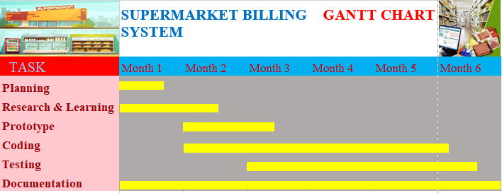

Fig 4.12: Gantt chart

# Chapter 5 expected output

As our project is small we have not expected more output from it. From our project we output information about the product and goods. It gives security to the admins and customers details. Here admins have to register and login to use the system core features. System will print bill automatically when the payment is done providing the details of customer buoyed products. It must print all the purchase details. This projects displays the goods and services available in supermarket in the screen to make customer easier to choose and buy products. Gives the detailed information of stock in the store to the admins. This project must help to mobilize the use of human resources. It provides flexibility in saving data’s in database which is important for any type of store.

# chapter 6 Testing

Testing in a project development is a very important task to find out the possible mistakes made by the developers. The system cannot give the correct output until the project contains no errors at all.

Once system implementation is done, system testing will be performed to testing on system performance .System testing is an important process in system development project. It will perform after development process which the actual system or prototype is created. Testing phase is very useful and important because this process able to trickle out the errors inside the software. Normally testing criteria is based on user and system requirements, to verify whether the system meet the requirements or not. System reliability is very important for a system to the end users and testing process able to verify the reliability of the system.

System testing may divide two parts which is unit testing and module integration testing. Unit testing is a kind of testing on each of the individual component in a large system. Before modules integration, unit testing performed on each module able to ensure that every module is working perfectly. The module integration testing would be a testing on the process of combination of all modules. Once all modules able to communicate with each other’s, the final system is done and the integration testing would test on the complete system.

## 6.1 Unit Testing

**Test Case 1: Input & Operations – Unit Testing**

|  |  |  |  |  |
| --- | --- | --- | --- | --- |
| No. | Test Objective | Test Step | Expected result | Result |
| 1. | To ensure that system take all inputs successfully. | 1. Give input to every part of software. 2. Observe the input data receive from user. | All the inputs must be taken correctly and operations of it should be performed correctly. | Pass |
| 2. | To ensure Operations are completed successfully. | 1. Code compilation is done. 2. Run code is performed. | Code compilation and code run must be successfully performed. | Pass |

Table 6.1: Input & Operations – Unit Testing

**Test Case 2: Output – Unit Testing**

|  |  |  |  |  |
| --- | --- | --- | --- | --- |
| No. | Test Objective | Test Step | Expected result | Result |
| 1. | To ensure that output is correct & according as per needed. | 1. Run the code 2. Output is observed. | Code should be run properly & output must give smoothly & correctly. | Pass |

Table 6.2: Output - Unit Testing

# chapter 7 conclusion & further works

Hence after the completion of the project we got familiar with the C++ programming and its features. A complete and useful Supermarket Billing system can only be developed with lot of intensive effort and time. Due to lack of time and we are beginners in programming program that we expected can't be developed by us. Our Supermarket Billing system may not be must useful for markets now, but it will be the most useful for study and programming practice using C++.

As a whole, the project has been a good learning experience for us. We have gained knowledge about the various aspects of C++ programming. At the same time, we have developed a deep understanding about the class & objects, inheritance & file handlings, etc. in C++ programming. We still want to emphasize that the program is not complete by itself. There is still a lot of room for improvement.

**Scope in Business Field**

Business communities now requires advanced supermarket billing systems giving number of advanced options and use to access online browsing. Now a day's supermarket billing systems have become so complicated that now different elite express communities have launched local as well as online supermarket billing system which control and handle data with security and ease of access.

**Learning from Project**

Basics of File handling, using of “class & objects”, “inheritance” & functions, etc is cleared. Many statements and codes and predefined functions which our group had not used before are practically used in this project which help me to study them in detail. Our group had learned is how to restrict the user throughout the program in different areas of input.

**Drawbacks**

Any program cannot be 100% reliable and efficient. This program also has some drawbacks which are given below:

* Graphics are not used so it is less attractive.
* Cannot be used in physical world.
* Multiple admins can’t access at once.
* Passwords cannot be changed once created.
* Less security.

**Further Works**

A number of possible upgrades were apparent which include: -

* Graphics can be used to make it more attractive.
* It can be applied to the physical world after upgrading more features.
* It can be made to access from multiple admins.
* Passwords changeable options can be given after upgrading project.
* Security can be made high.

# References

[1]Supermarket Billing System in C++ with source code, Sourcecodehero, Nov 4, 2021, <https://sourcecodehero.com/supermarket-billing-project-in-c-with-source-code/>

[2]Supermarket Billing System Project in C++ | Project for Beginners, Simplilearn, <https://www.youtube.com/watch?v=xFwwN4lGG0o>

[3]Supermarket Billing System in C++ with source code 2021, itsourcecode, <https://www.youtube.com/watch?v=JiXK4H14Q_Q>

[4]Supermarket Billing System a mini project in c++, StuDocu, Rajalaxmi Engineering College, Chennai, <https://www.studocu.com/in/document/the-oxford-educational-institutions/healing-her-heart/supermarket-billing-system-in-c/23281615>

[5]Diagrams (Flowchart, Block diagram, Activity diagram), Untitled Diagram, <https://app.diagrams.net/>

# appendix

**User manual**

1. 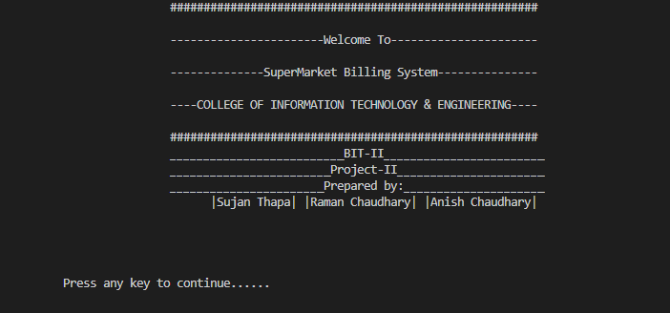Front Console window

Fig (a): Front Console window

1. Main menu window

Fig (b): Main menu window

1. Registration window

Fig (c): Registration window

1. Login window



Fig (d): Login window

1. Buyer window

Fig (e): Buyer window

1. Forgot Password window

Fig (f): Forgot password window

1. 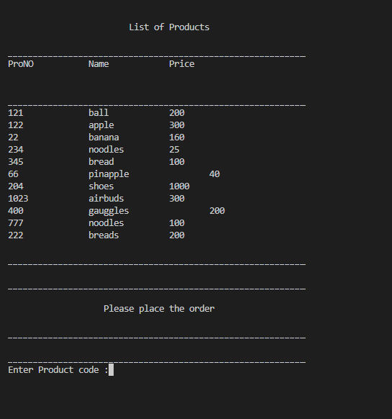Buy Product window

Fig (g): Buy product window

1. 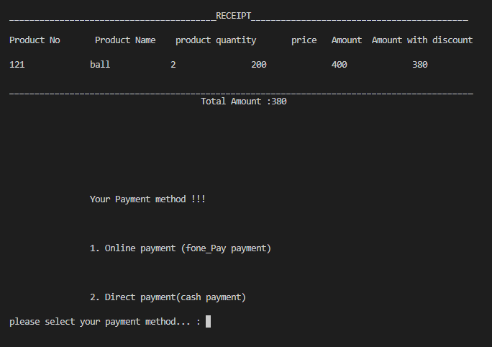Payment Window

Fig (h): Payment window

* Online Payment (fone pay)

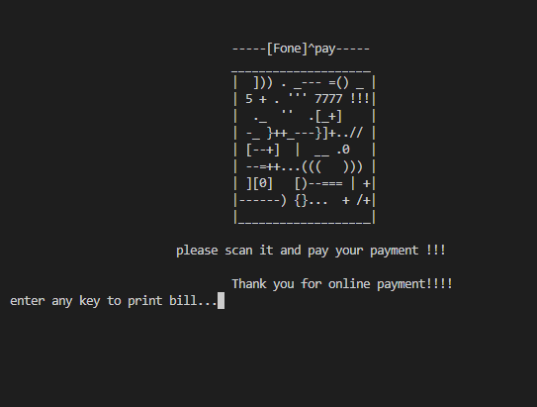

Fig (i): Online Payment window

* 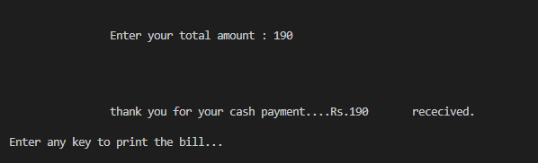Direct Payment (Cash )

Fig (j): Direct payment window

1. 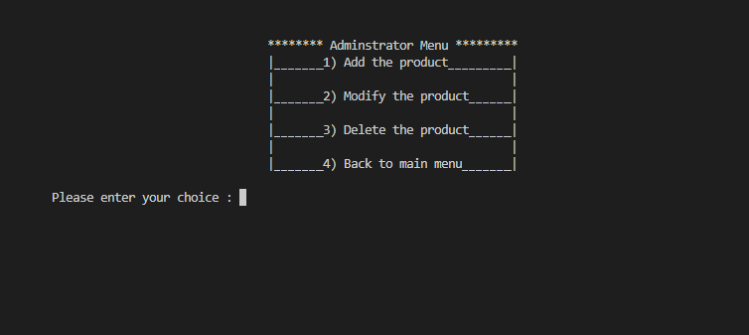Admin menu

Fig (l): Admin menu window